CS2S567 Professional Practice and Employability:
Team Based Software Development Workshop

Team Portfolio

By
Phase 3
Written by Jessica Fealy - 18024092

Team GitHub Link :
https://github.com/BenB33/ProfessionalismTeam2

Team Number | 2
Team Task | Create a PIM system:  - Research TKinter  - Research SQLite  - Research and write a LESPI  - Research and write a QA Document  - Create flowcharts  - Create a prototype  - User guide  - Completed Project  - Vulnerabilities Documentation  - Quality assurance document  - Final Document
Team Members | Jessica Fealy  Ben Harrison  Komal  Harry  Ed

Overview
During phase 3 the teams collectively completed all final documentation, senimar and completed the final solution for our PIM system.

Seminar
During phase 3 our team completed a seminar to discuss the contributions and overall development of the project, with each team member completing several slides with commentary. This was done in video format which also allowed the teams to speak as a collective about the final PIM solution.

Vulnerabilities
The vulnerability document has a combined team effect with 3 team members participating. These team members for Harry ( Producer and Researcher ), Ed ( Researcher ), and Jess ( Producer and Researcher ), these vulnerabilities were taken into account for . The team researched and Harvard referenced the following topics:
- Port Vulnerabilities
- SQL Injection
- Software Vulnerabilities
- Integer overflow
- Buffer Overflow
- Data Vulnerabilities
- Logging Vulnerabilities
- Using component with known vulnerabilities
- Broken Authentication

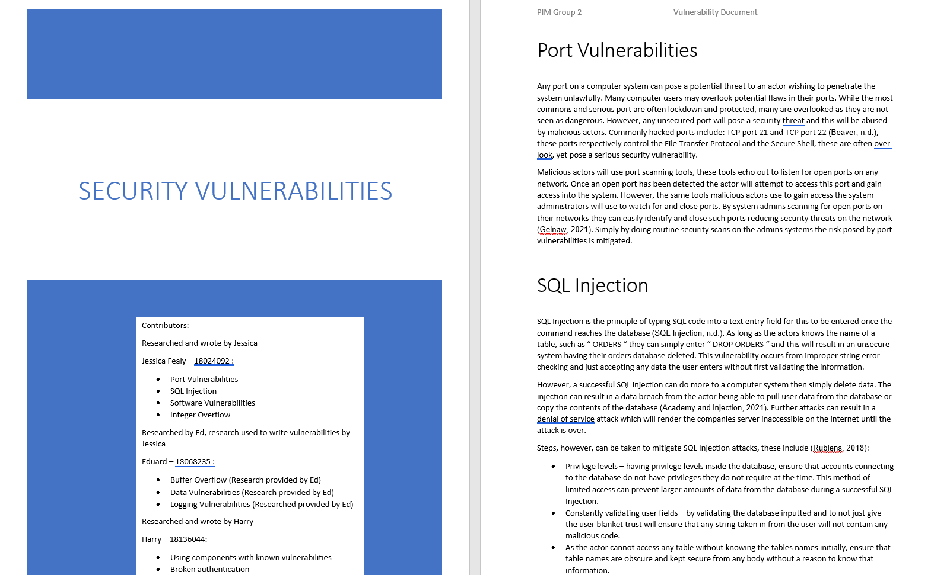

User Guide
The user guide for the PIM system required a team meeting to discuss the contents of the guide, with Jessica and Ben being appointed responsible for the outcome of the User Guide. Jessica and Ben decided that Jess will write the User Guide, and Ben (being the main programmer to the PIM system) will give technical input and provide the screenshots of the PIM system in operation.

Final Document
The final document was written by Jessica, upon communicating that the team had forgotten about this document. The team had a meeting to discuss the points in which should be discussed in the document. The document was finished and reviewed by the team.

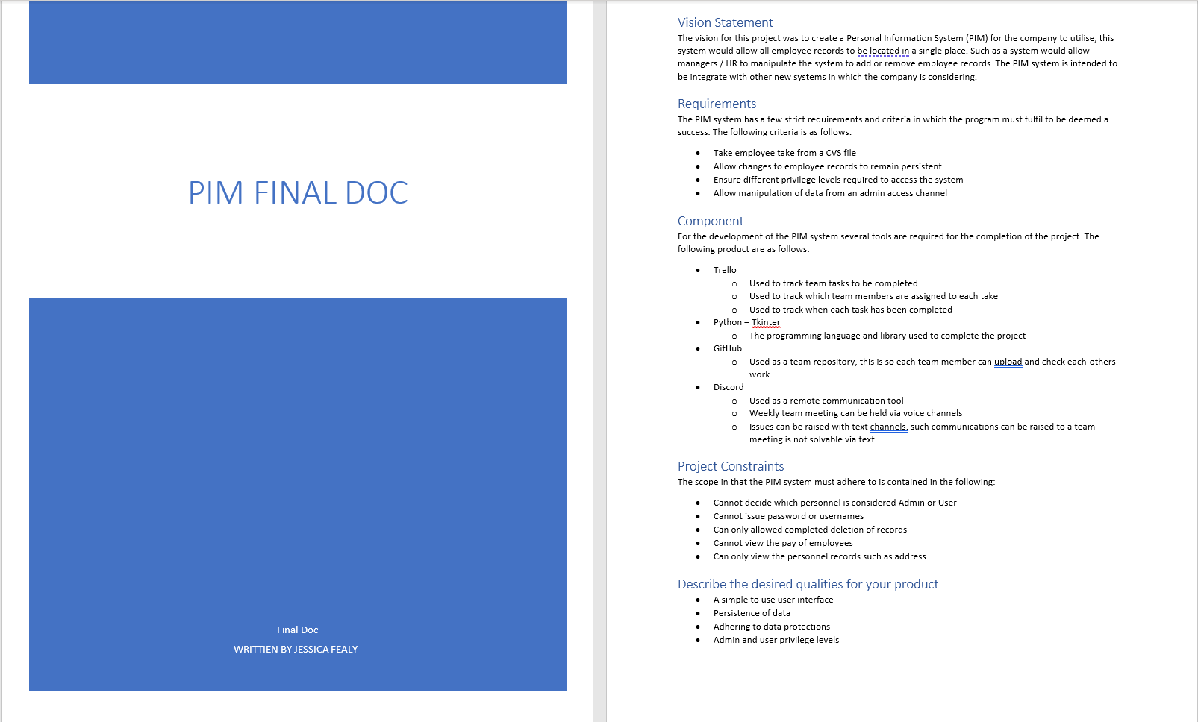

Teamwork
The team has work in a cooperative manner, utilising tools such as Github, Discord, and Trello.
Using Trello we were able to manage and track tasks in which each team member were assigned, doing so allowed us to ensure a fair and equal distribution of work.
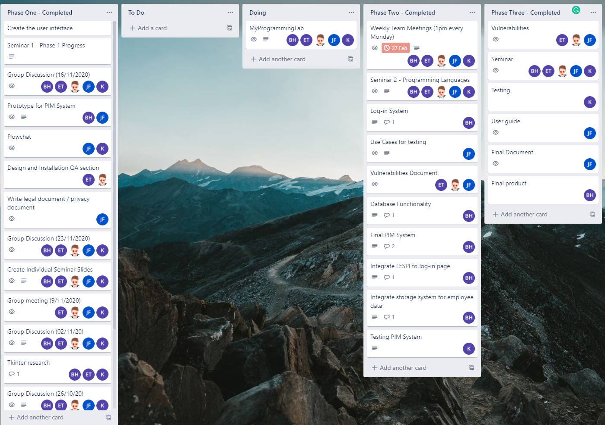

Discord throughout all 3 phases has been the main source of communication between teams members for this project, with weekly teams meetings taking place each Monday. These meetings were postponed indefinitely from the end of Phase 2, with intermittent meetings taking place when required.
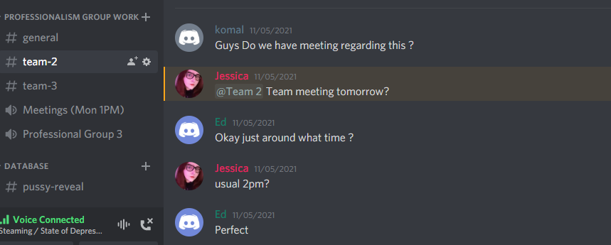

GitHub has been the teams main repository for all 3 phases, with all worked related to be project being uploaded, this has allowed us to track and check each other’s work.
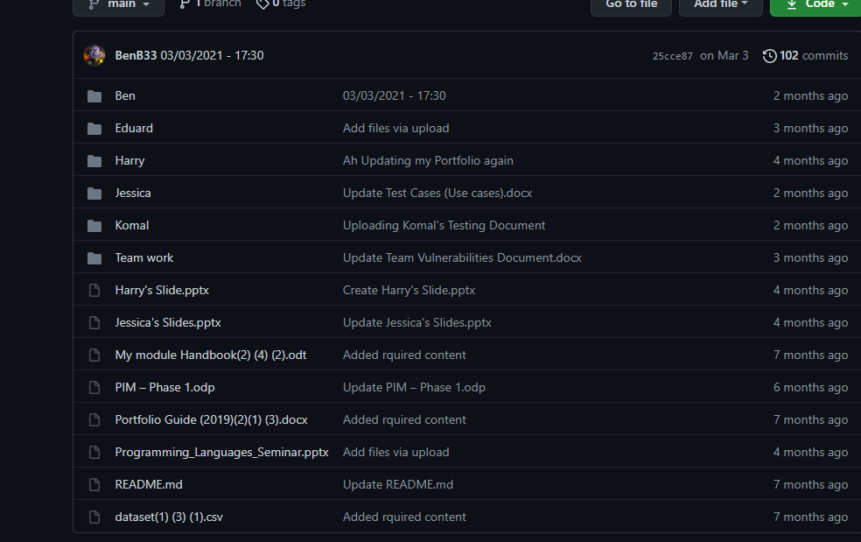

Final Solution
The final solution was contributed to by all team members either directly or nondirectly. All teams members are satisfied with the overall outcome. With the final PIM solution solving the needed criteria given, primarily the system is pulling employee data from a CVS file, and requires user log in credentials where each user can be given different privilege levels.
The final user interface for both the admin and user accounts can be found below:
